2.8.1 Apply Option Additions

Brief Description
This use case models the steps Market Operations uses to implement the list of daily option additions.

Flow of Events

Basic Flow
- The Market Operations Staff applies options additions that are in the maintained list from the generated options.
- The Market Operations Staff selects apply options additions item.
- The system validates the entered data.
- The system saves the data persistently.
- Trading floor systems are updated with new information.
- Messages are sent to trading floor systems that contain the underlying product symbol, the reporting class symbol, post and station, option cycle, position limits, date of trading activation, option expiration months, strike prices and OPRA codes. The systems are TIPS, PDS, Legacy ICS and MSS.

Alternative Flows

TBD

Relationships

Actors:
Market Operations Staff
TIPS
PDS
Market Surveillance System
Integrated Class System

Uses and extends associations with:

Use-Case Diagrams

Apply Option Additions UCD

Special Requirements

Performance

Security

Preconditions

List of options is approved
The list has been generated and is approved.

Additions will fit into strike map
Added options will fit in the exercise price map of all reporting classes.

Postconditions

Pictures of the User Interface

2.8.2 Create FLEX Option

Brief Description
This uses case model the creation of a FLEX option.

Flow of Events

Basic Flow
- The Help Desk Staff receives requests to list a FLEX option.

Alternative Flows

TBD

Relationships

Actors:
Help Desk Staff

Uses and extends associations with:

Use-Case Diagrams

Create FLEX Option UCD

Special Requirements
TBD

Performance

Security

Preconditions

TBD
TBD

Postconditions

TBD

Pictures of the User Interface

2.8.3 Create New Reporting Class

Brief Description
This use case models the steps that Market Operations uses to create a new reporting class for a product class.

Flow of Events

Basic Flow
- The Market Operations Staff receives a request to add a new reporting class
- The Market Operations Staff selects the add new reporting class item.
- The system displays a screen for entering the following information:
- Reporting class symbol
- Select underlying product symbol from a list
- Multiplier
- Primary Exchange
- Other Exchanges
- Post and Station
- The Market Operations Staff enters appropriate data into all fields.
- Syntactic checking is performed on a field by field basis to insure that entered data conforms to required formats
- When the field editing is completed, the Market Operations Staff clicks on the SAVE button.
- The system validates the entered data.
- The system saves the data persistently.

Alternative Flows

Data is Invalid
- The system encounters invalid data and will display an error message to the user.
- The Market Operations Staff re-enters the invalid data as valid end clicks save.
- The system validates the entered data.
- The system saves the data persistently.

Relationships

Actors:
Market Operations Staff

Uses and extends associations with:

Use-Case Diagrams

Create New Reporting Class UCD

Special Requirements
The generated documents should reflect the current manually entered documents. The documents should also be editable by a word processor.

Performance

Security

Preconditions

Postconditions

Pictures of the User Interface
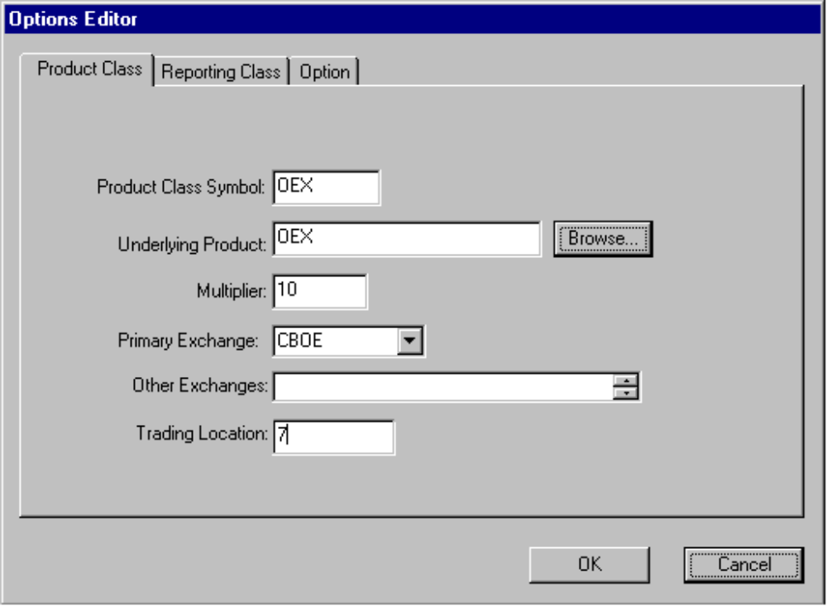

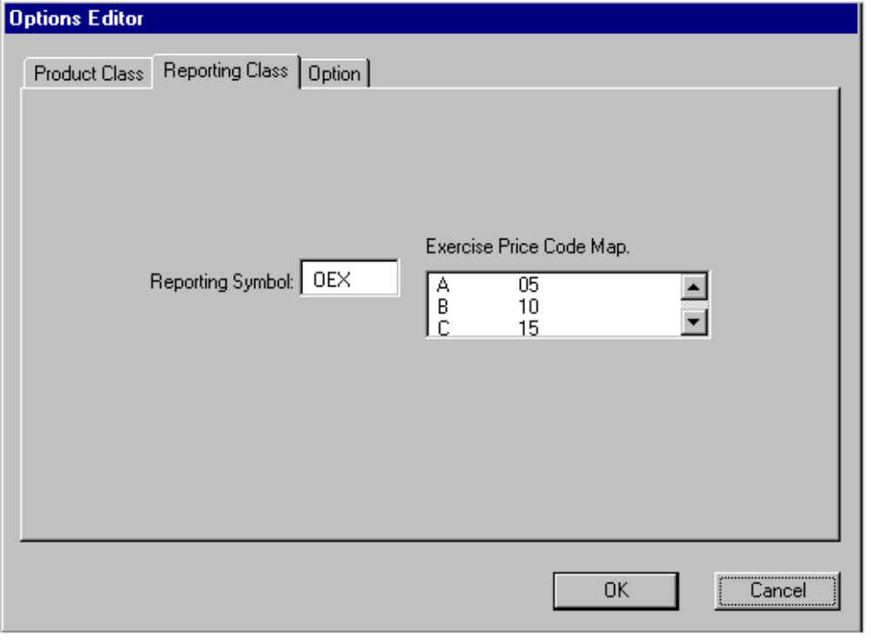

2.8.4 Generate Option Additions

Brief Description
This use case models the steps Market Operations uses to generate a suggested list of options to add to product classes.

Flow of Events

Basic Flow
- The system at a specified time starts generating a list of options to add.
- The system checks underlying prices from an external source (i.e., TIPS, ILX).
- The system calculates based on an internal parameter if an options set for a product is outside the calculated range.
- The system generates a temporary option put into a list for review by the Market Operations Staff.
- The system generates a document that is distributed to the floor for review.

Alternative Flows

No Additions Generated
- The system displays a message the no options were generated.

Relationships

Actors:
Market Operations Staff
Trader

Uses and extends associations with:

Use-Case Diagrams

Generate Option Additions UCD

Special Requirements

Performance

Security

Preconditions

Market information is available
The external market information resources are available (i.e., TIPS, ILX).

Postconditions

No price adjusted options specified
The generated list does not contain additions for options whose underlying product has a pending price adjustment.

No classes with multiplier change
The generated list does not contain additions for options whose product class that had it’s multiplier changed by a price adjustment.

Pictures of the User Interface

2.8.5 Handle External Market Information

Brief Description
This use case models the required interactions between TIPS and the Trading Engine software when TIPS sends relevant stock data to the Trading Engine.

Flow of Events

Basic Flow
- The system connects to the TIPS system with TCP/IP.
- The system sends a message to request information on a product with the following information
- Product symbol
- Exchange identifier
- The system receives a response for the request with the following information:
- Product Symbol
- Exchange identifier
- Last sale value
- High value
- Low value
- Bid value
- Ask value
- Market indicators (Fast, Halt, etc.)
- The system saves the information with the product.

Alternative Flows

Retrieve data from ILX
- The system connects to the ILX system.
- The system sends a message to request information on a product with the following information
- Product symbol
- Exchange identifier
- The system receives a response for the request with the following information:
- Product Symbol
- Exchange identifier
- Last sale value
- High value
- Low value
- Bid value
- Ask value
- Market indicators (Fast, Halt, etc.)
- The system saves the information with the product.

Invalid product request
- The system receives an error message from the external market information system.
- The system generates an error report that specifies the product market information could not be retrieved.

Relationships

Actors:
TIPS
ILX
TIPS

Uses and extends associations with:

Use-Case Diagrams

Handle External Market Information UCD

Special Requirements
Custom interfaces need to be built to support the connections to these systems.

Performance

Security

Preconditions

The product information is available on the external system.

Postconditions

Pictures of the User Interface

2.8.6 LEAPS Rollover

Brief Description
This use case models the steps that Market Operations uses to move options of a LEAP class to a regular class.

Flow of Events

Basic Flow
- The Market Operations Staff receives a request to rollover a LEAPS class.

Alternative Flows

TBD

Relationships

Actors:
Market Operations Staff

Uses and extends associations with:

Use-Case Diagrams

LEAPS Rollover UCD

Special Requirements
TBD

Performance

Security

Preconditions

TBD
TBD

Postconditions

TBD

Pictures of the User Interface

2.8.7 List Index

Brief Description
This use case models the steps that Research uses to create a new index whose components are all stocks.

Flow of Events

Basic Flow
- The Research Staff receives requests to list an index.
- The Research Staff selects the add new index item.
- The system displays a screen for entering the following information:
- Product symbol
- Index name
- Primary exchange
- Post and station
- Date of activation
- Dissemination interval
- Dissemination of index value - internal or external
- Dissemination of bid/ask index value - internal or external
- Index divisor
- Component descriptions for each product in the index
- Product symbol
- Exchange
- Share amount
- The Research Staff enters appropriate data into all fields.
- Syntactic checking is performed on a field by field basis to insure that entered data conforms to required formats
- When the field editing is completed, the Research Staff clicks on the SAVE button.
- The system validates the entered data.
- The system saves the data persistently.
- The system will retrieve component product last sale information and calculate the index value for review on the screen.
- Trading floor systems are updated with new information.
- Messages are sent to trading floor systems that contain the Product symbol, post and station and date of trading activation. The systems are TIPS and PDS.

Alternative Flows

Data is Invalid
- The system encounters invalid data and will display an error message to the user.
- The Research Staff re-enters the invalid data as valid end clicks save.
- The system validates the entered data.
- The system saves the data persistently.

Relationships

Actors:
Research Staff
TIPS
PDS

Uses and extends associations with:

Use-Case Diagrams

List Index UCD

Special Requirements

Performance

Security

Preconditions

Products for components exist
All products used as an index component have already been entered in the system.

Postconditions

Pictures of the User Interface
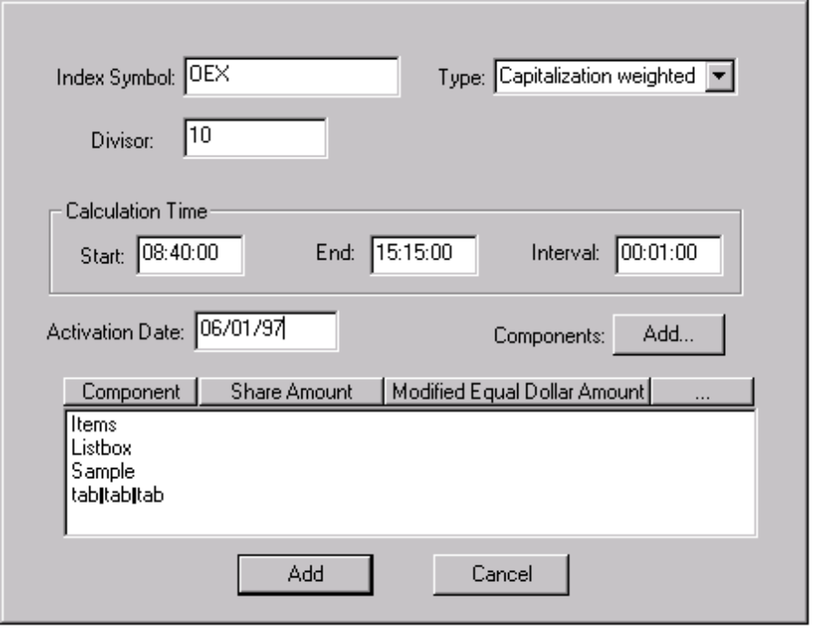

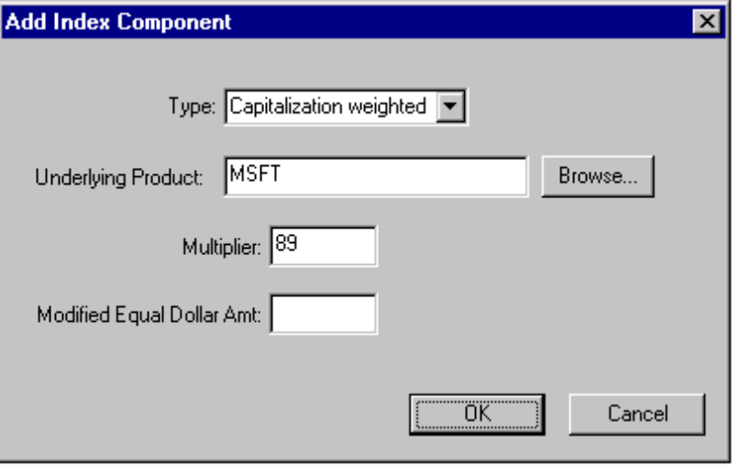

2.8.8 List New Options

Brief Description
This use case models the steps that Research uses to add a new option.

Flow of Events

Basic Flow
- The Research Staff receives requests to list a “class” of options for a specific product.
- The Research Staff selects the add new options item.
- The system displays a screen for entering the following information:
- Create reporting class (See Use Case)
- Post and station
- Option cycle (Quarterly - Jan, Feb or March, Other)
- Position limits
- Date of trading activation
- Enter in individual option information
- Type - call or put
- Expiration month
- Strike price
- OPRA codes
- DPM/Crowd support
- Listing type - single or dual
- Listing Exchanges
- The Research Staff enters appropriate data into all fields.
- Syntactic checking is performed on a field by field basis to insure that entered data conforms to required formats
- When the field editing is completed, the Research Staff clicks on the SAVE button.
- The system validates the entered data.
- The system saves the data persistently.
- Documents are generated for distribution internally or externally.
- A New Listing Document that contains boilerplate, the company name of the underlying product, the underlying product symbol, the reporting class symbol, post and station, option cycle, position limits, date of trading activation, option expiration months, strike prices and OPRA codes. This is distributed internally and to the floor.
- A Listing Certificate Document that contains boilerplate, the company name of the underlying product and the underlying product symbol. This is for the SEC and OCC.
- A Member Firm New Listing Document that contains boilerplate, the company name of the underlying product, the underlying product symbol, DPM/Crowd support, option cycle, strike prices, position limits and date of trading activation. This is distributed to member firms.
- An Internal Listing document that contains the company name of the underlying product, the underlying product symbol, the reporting class symbol, post and station, option cycle, position limits, date of trading activation, option expiration months and strike prices This is distributed internally.
- Trading floor systems are updated with new information.
- Messages are sent to trading floor systems that contain the underlying product symbol, the reporting class symbol, post and station, option cycle, position limits, date of trading activation, option expiration months, strike prices and OPRA codes. The systems are TIPS, PDS, Legacy ICS and MSS.

Alternative Flows

Invalid field data
- The Research Staff re-enters the invalid data.
- The system validates the entered data.
- The system saves the data persistently.

Relationships

Actors:
Research Staff
OCC
System Operations Staff
Trader
Book Staff
Help Desk Staff
Market Operations Staff
Integrated Class System
Market Surveillance System
TIPS
PDS

Uses and extends associations with:
Uses Create New Reporting Class

Use-Case Diagrams

List New Options UCD

Special Requirements
There will be approximately 45000 option products defined floor wide and approximately 510 options added per month. The system shall have the resources to persistently store this amount of data.
The generated documents should reflect the current manually entered documents. The documents should also be editable by a word processor.

Performance

Security

Preconditions

Underlying product exists
The underlying product has already been entered into the system.

Postconditions

Documents are printed
The appropriate documents have been printed.

Pictures of the User Interface

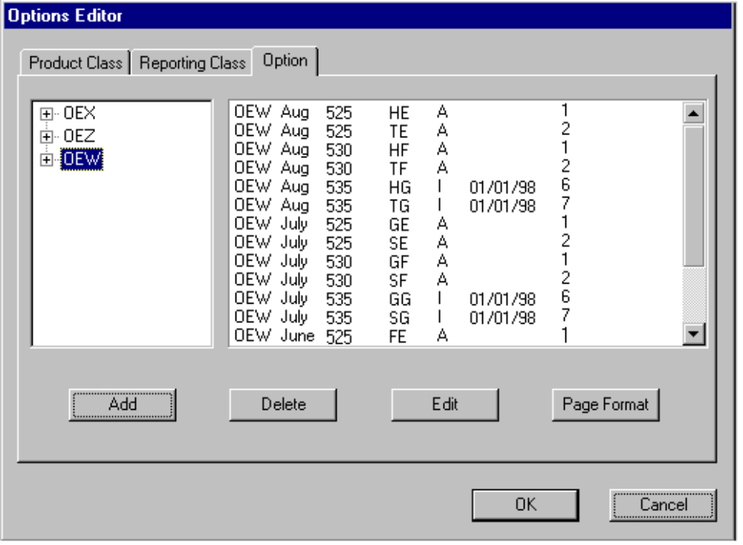

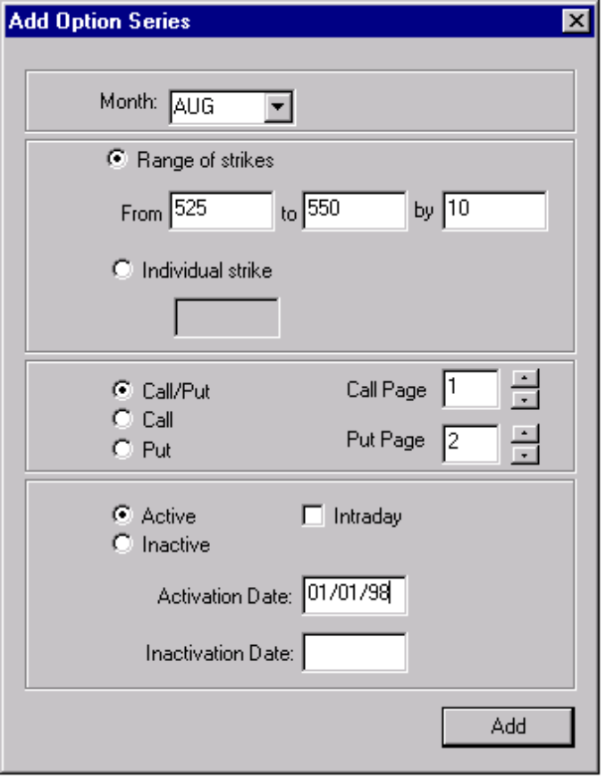

2.8.9 List New Stocks

Brief Description
This use case models the steps that Research uses to add a new common stock.

Flow of Events

Basic Flow
- The Research Staff receives requests to list a “class” of options for a specific product.
- The Research Staff selects the add new stock item.
- The system displays a screen for entering the following information:
- Product symbol
- Company name
- Primary exchange
- Post and station
- Date of trading activation
- The Research Staff enters appropriate data into all fields.
- Syntactic checking is performed on a field by field basis to insure that entered data conforms to required formats
- When the field editing is completed, the Research Staff clicks on the SAVE button.
- The system validates the entered data.
- The system saves the data persistently.
- Trading floor systems are updated with new information.
- Messages are sent to trading floor systems that contain the Product symbol, post and station and date of trading activation. The systems are TIPS, PDS, Legacy ICS and MSS.

Alternative Flows

Data is Invalid
- The system encounters invalid data and will display an error message to the user.
- The Research Staff re-enters the invalid data as valid end clicks save.
- The system validates the entered data.
- The system saves the data persistently.

Relationships

Actors:
Research Staff
TIPS
PDS
Market Surveillance System
Integrated Class System

Uses and extends associations with:

Use-Case Diagrams

List New Stocks UCD

Special Requirements

Performance

Security

Preconditions

Company does not exist
The company will need to be created.

Exchange exists
The primary exchange has already been entered in the system.

Add as inactive
The stock will be add as inactive.

Postconditions

Company has been created
The company will now be entered in the system.

Pictures of the User Interface
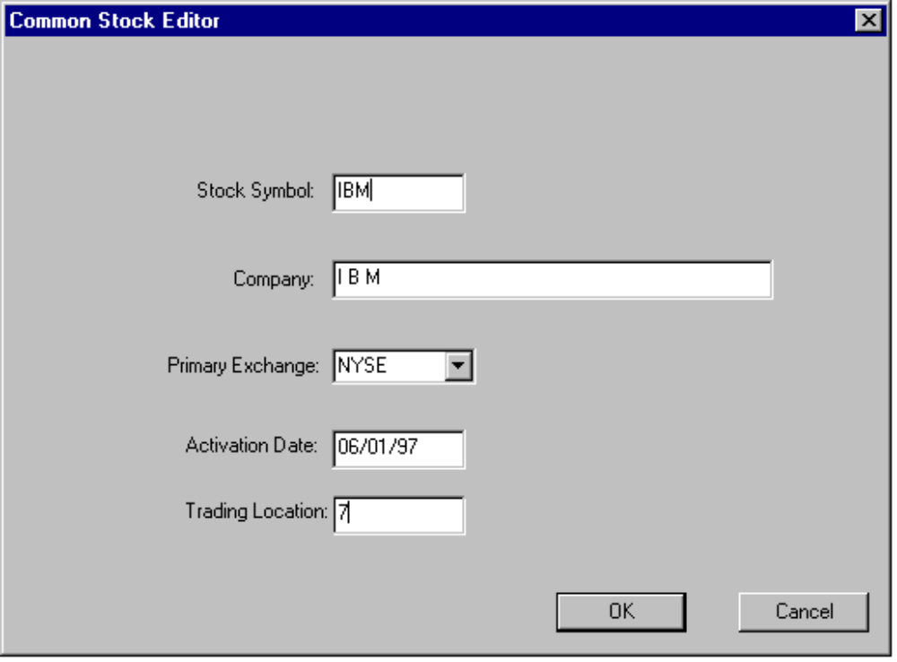

2.8.10 Maintain Expiration Procedures for Options

Brief Description
This use case models the steps that Market Operations uses to expire options and create new options for the next active expiration period.

Flow of Events

Basic Flow
- The Market Operations Staff expires options on their specified day.

Alternative Flows

TBD

Relationships

Actors:
Market Operations Staff

Uses and extends associations with:

Use-Case Diagrams

Maintain Expiration Procedures for Options UCD

Special Requirements
TBD

Performance

Security

Preconditions

TBD
TBD

Postconditions

TBD

Pictures of the User Interface

2.8.11 Maintain Index

Brief Description
This use case models the steps that Research and Market Operations uses to manage the components and attributes for the definition of an index.

Responsibilities:
- Maintain index definition.

Flow of Events

Basic Flow
- The Research Staff receives requests to change a component in an index.
- The Research Staff selects the edit index item.
- The system displays a screen for entering the following information:
- Product symbol
- Index name
- Primary exchange
- Post and station
- Date of activation
- Dissemination interval
- Dissemination of index value - internal or external
- Dissemination of bid/ask index value - internal or external
- Index divisor
- Component descriptions for each product in the index
- Product symbol
- Exchange
- Share amount
- The Research Staff modifies the data in fields.
- Syntactic checking is performed on a field by field basis to insure that entered data conforms to required formats
- When the field editing is completed, the Research Staff clicks on the SAVE button.
- The system validates the entered data.
- The system saves the data persistently.
- The system will retrieve component product last sale information and calculate the index value for review on the screen.
- Trading floor systems are updated with new information.
- Messages are sent to trading floor systems that contain the Product symbol, post and station and date of trading activation. The systems are TIPS, PDS, Legacy ICS and MSS.

Alternative Flows

Rebalance Index

Relationships

Actors:
Research Staff
Market Operations Staff
TIPS
PDS

Uses and extends associations with:

Use-Case Diagrams

Maintain Index UCD

Special Requirements

Performance

Security

Preconditions

Postconditions

Pictures of the User Interface
See List Index use case.

2.8.12 Maintain Option

Brief Description
This use case models the steps that Market Operations uses to maintain information about existing options.

Responsibilities:
- Change product trading location.
- Change product symbol.
- Change primary exchange of product.
- Activate a product with pending active status.
- Inactivate idle options.
- Change reporting class

Flow of Events

Basic Flow
- The Help Desk Staff receives a request to update an option’s parameters
- The Help Desk Staff selects the edit options item.
- The system displays a screen for entering the following information:
- Select underlying product symbol from a list
- Post and station
- Option cycle (Quarterly - Jan, Feb or March, Other)
- Position limits
- Date of trading activation
- Enter in individual option information
- Type - call or put
- Expiration month
- Strike price
- OPRA codes
- DPM/Crowd support
- Listing type - single or dual
- Listing Exchanges
- The Help Desk Staff enters appropriate data into all fields.
- Syntactic checking is performed on a field by field basis to insure that entered data conforms to required formats
- When the field editing is completed, the Help Desk Staff clicks on the SAVE button.
- The system validates the entered data.
- The system saves the data persistently.
- Trading floor systems are updated with new information.
- Messages are sent to trading floor systems that contain the underlying product symbol, the reporting class symbol, post and station, option cycle, position limits, date of trading activation, option expiration months, strike prices and OPRA codes. The systems are TIPS, PDS, Legacy ICS and MSS.

Alternative Flows

Activate a product with pending active status

Inactivate idle options

Change reporting class

Relationships

Actors:
Market Operations Staff
TIPS
PDS
Market Surveillance System
Integrated Class System

Uses and extends associations with:

Use-Case Diagrams

Maintain Option UCD

Special Requirements

Performance

Security

Preconditions

The option must exist.

Postconditions

Pictures of the User Interface
See List New Option use case.

2.8.13 Maintain Option Additions

Brief Description
This use case models the steps Market Operations uses to update the list of daily option additions.

Flow of Events

Basic Flow
- The Market Operations Staff maintains options additions daily after the distribution and response of the generated options.
- The Market Operations Staff selects the maintain option additions item.
- The Market Operations Staff selects and deselects the additions based on the review information.
- The Market Operations Staff may add an option that was not generated.

Alternative Flows

TBD

Relationships

Actors:
Market Operations Staff

Uses and extends associations with:

Use-Case Diagrams

Maintain Option Additions UCD

Special Requirements

Performance

Security

Preconditions

Options additions have been generated
The list has been generated and there are entries.

Options additions are new
Options in the list are new and not existing as inactive.

Postconditions

Pictures of the User Interface
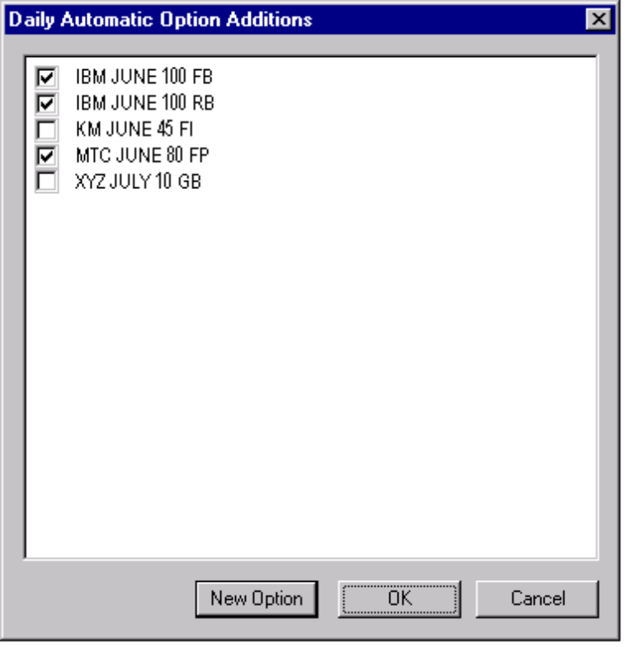

2.8.14 Maintain Stock

Brief Description
This use case models the steps that Market Operations uses to maintain information about existing stocks.

Responsibilities:
- Change product trading location.
- Change product symbol.
- Change primary exchange of product.
- Activate a product with pending active status.
- Change reporting class

Flow of Events

Basic Flow
- The Help Desk Staff receives a request to update a stock’s parameters
- The Help Desk Staff selects the edit stock item.
- The system displays a screen for entering the following information:
- Company name
- Primary exchange
- Post and station
- Date of trading activation
- The Help Desk Staff enters appropriate data into all fields.
- Syntactic checking is performed on a field by field basis to insure that entered data conforms to required formats
- When the field editing is completed, the Help Desk Staff clicks on the SAVE button.
- The system validates the entered data.
- The system saves the data persistently.
- Trading floor systems are updated with new information.
- Messages are sent to trading floor systems that contain the Product symbol, post and station and date of trading activation. The systems are TIPS, PDS, Legacy ICS and MSS.

Alternative Flows

Activate a product with pending active status

Relationships

Actors:
Market Operations Staff
TIPS
PDS
Market Surveillance System
Integrated Class System

Uses and extends associations with:

Use-Case Diagrams

Maintain Stock UCD

Special Requirements

Performance

Security

Preconditions

Postconditions

Pictures of the User Interface
See List New Stock use case.

2.8.15 Perform Price Adjustment

Brief Description
This use case models the steps that Research uses to enter a change in the price of a base product that requires changes to be made to derivative products or index components.

Responsibilities:

- Handle N-for-1 split
- Handle Complex Split
- Handle Stock Dividend Distribution
- Handle Corporate Ownership Changes
- Activate Price Adjustment
- Modify Exercise Price Map
- Find Affected Products
- Find Affected Index Components
- Find Affected Index Components of a Base Product
- Find Affected Index Components of a Derivative Product
- Find Affected Derivative Products
- Find Affected Single Derivative Products
- Find Affected Multi-Derivative Product

Flow of Events

Basic Flow
- The Research Staff receives a request for an N-for-1 split of an underlying product.
- The Research Staff selects the price adjustment item.
- The system displays a screen with the following fields:
- Selection of price adjustment type
- Price adjustment information (free form text)
- Split ratio
- Dividend value
- Underlying Product
- Class to adjust
- Alternate class name
- Effective date
- Apply date
- The Research Staff enters that parameters in the fields for the price adjustment and clicks TRY.
- The system validates the fields.
- The system generates a list of options for the parameters given.
- The system displays a list of new options relative to the original options to the user for review.
- The Research Staff modifies the list by adding or deleting specific new options.
- The Research Staff is finished modifying the list and clicks OK.
- The system validates the entered data.
- The system persistently saves the data.
- The system will locate all uses of the underlying product that is used for a price adjustment and modify those products.
- The system generates documents for distribution.
- A Stock Split document will be generated that contains boilerplate, price adjustment information, company name, underlying product symbol, original reporting class, new reporting class, original options (expiration months, strikes, OPRA codes), new options relative to the original and effective date.
- Trading floor systems are updated with new information.
- Messages are sent to trading floor systems that contain for the original class and the new class the underlying product symbol, the reporting class symbol, post and station, option cycle, position limits, date of trading activation, option expiration months, strike prices and OPRA codes. The systems are TIPS, PDS, Legacy ICS and MSS.
- The Trade Engine will process the data in a temporary area.
- Orders will be found for the affected classes and the prices and quantities adjusted in an temporary copy accordingly and stored in a temporary list.

Alternative Flows

Handle Complex Split
- TBD

Handle Stock Dividend Distribution
- TBD

Handle Corporate Ownership Changes
- TBD

Activate Price Adjustment
- The system will notify the Trade Engine that the price adjustment is active.
- The Trade Engine will apply the temporary modifications to orders to the actual persistent orders.

Relationships

Actors:
Research Staff
Market Operations Staff
Trader
Booth Staff
System Operations Staff
Help Desk Staff
Book Staff
TIPS
PDS
Integrated Class System
Market Surveillance System

Uses and extends associations with:

Use-Case Diagrams

Perform Price Adjustment UCD

Special Requirements
TBD

Performance

Security

Preconditions

Product exists
The product that is being adjusted exists.

No pending adjustment
The product that is being adjusted has no pending adjustments.

Related product classes exist
The product that is being adjusted is an underlying product for one or more classes.

Postconditions

Pictures of the User Interface
